

Evac Remote

(ESSO)

Installation Instructions

# Download SQL Express

Download SQL Express ([SQLEXPR_x86_ENU.exe](http://willow.evacchair.co.uk/software/SQLEXPR_x86_ENU.exe)) from this location

<http://willow.evacchair.co.uk/software/>

Then run the program Installer

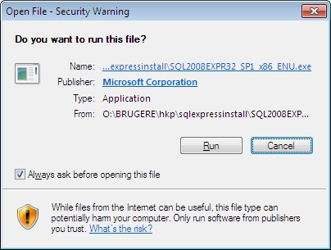

# Wait while the files are extracted and select Installation

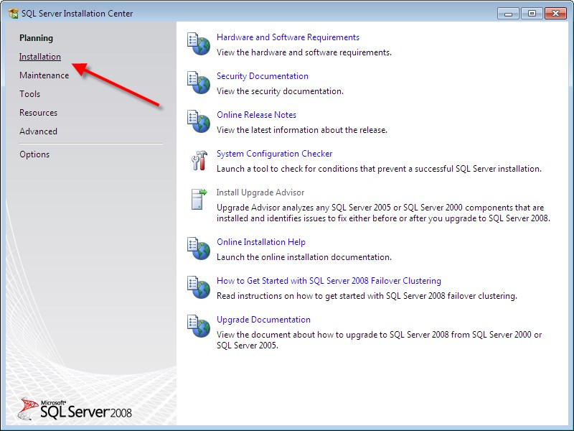

# Select ‘New SQL Stand Alone Installation’

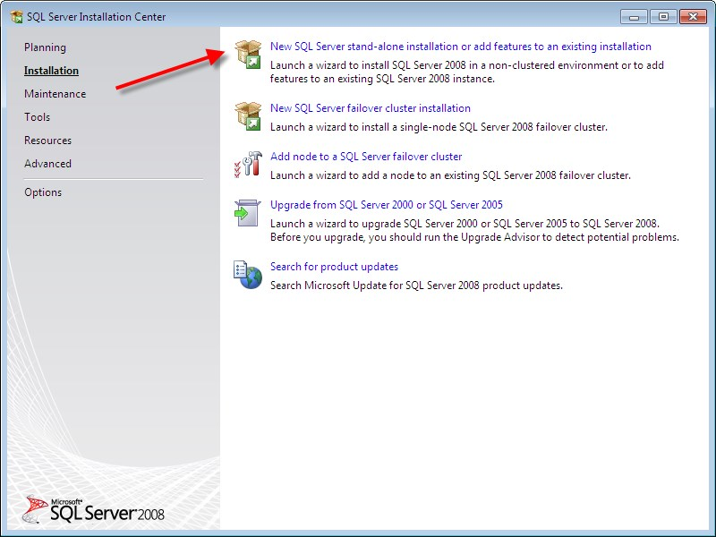

## A Reboot may be required

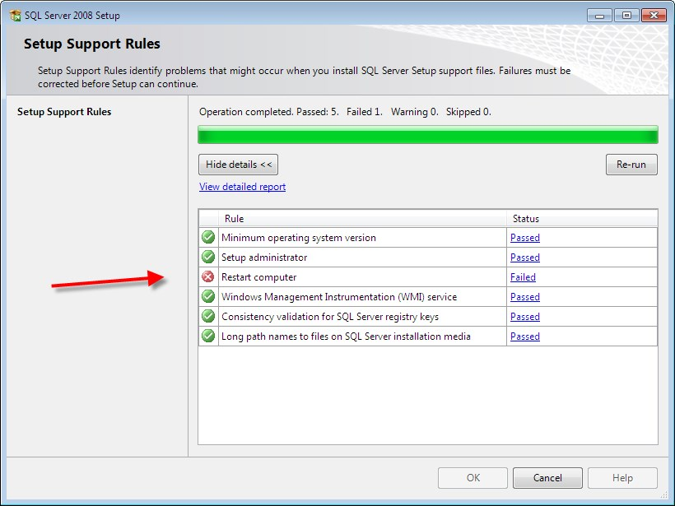

## 

## If so Reboot and repeat steps above

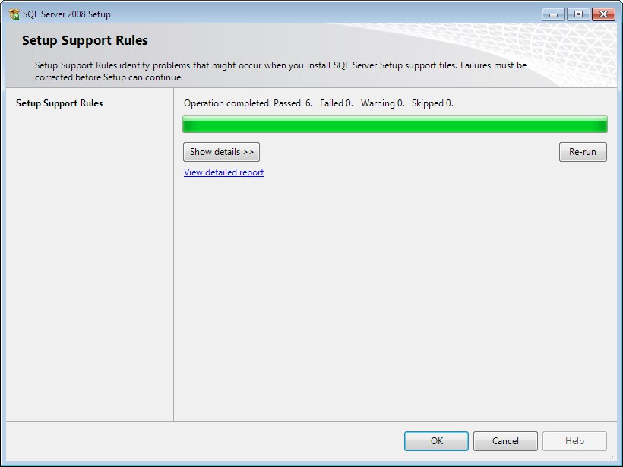

## 

## Hit next on the Product key screen (No Product key is required for this free version)

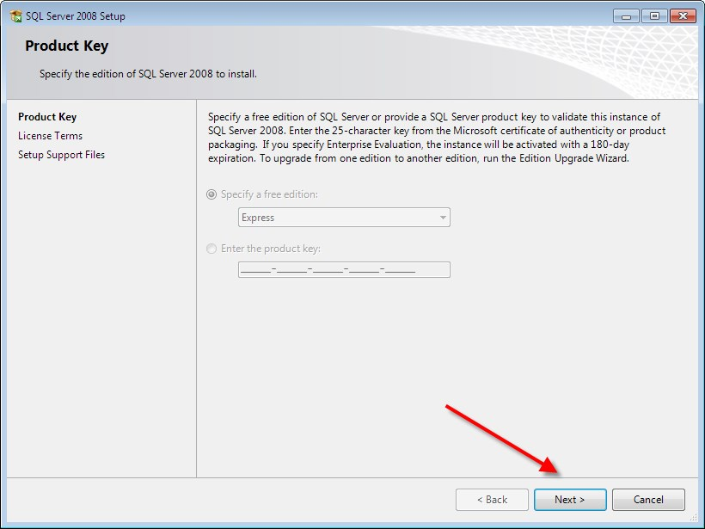

## Accept the License

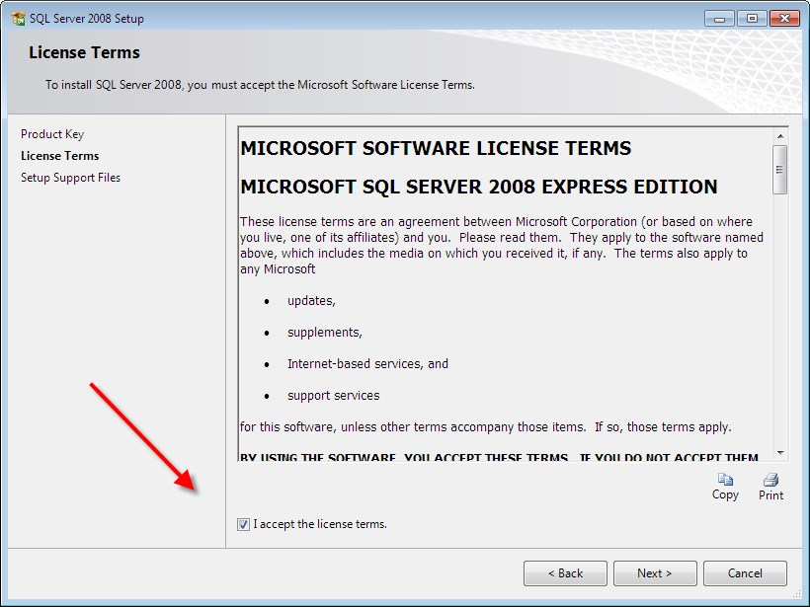

## Hit Install

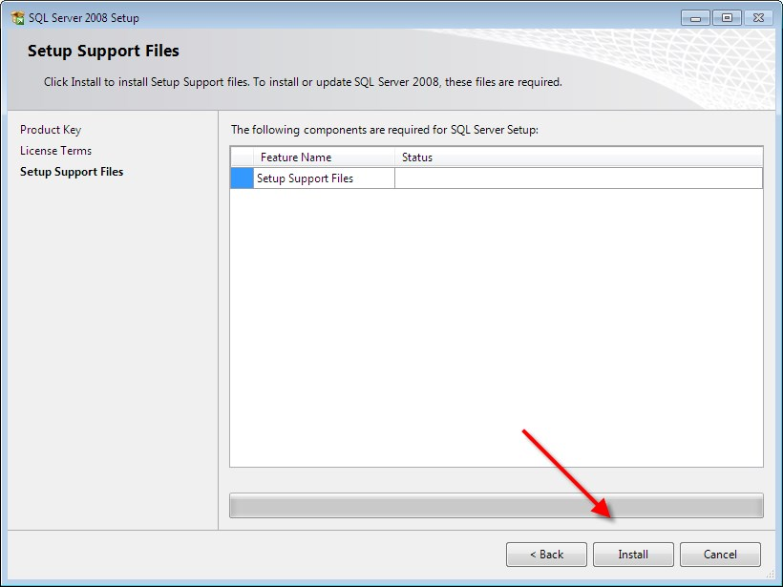

## Hit Next

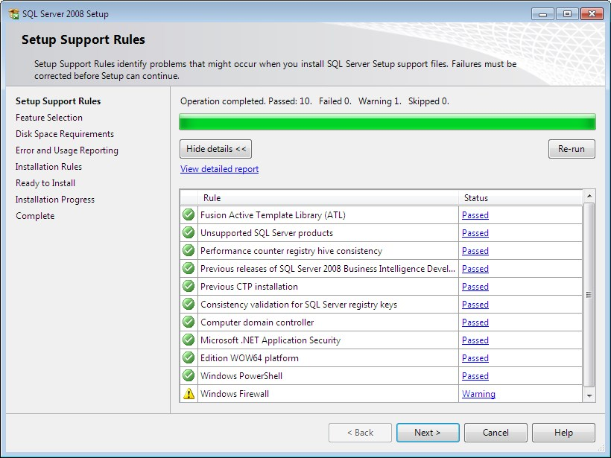

## Select All Features

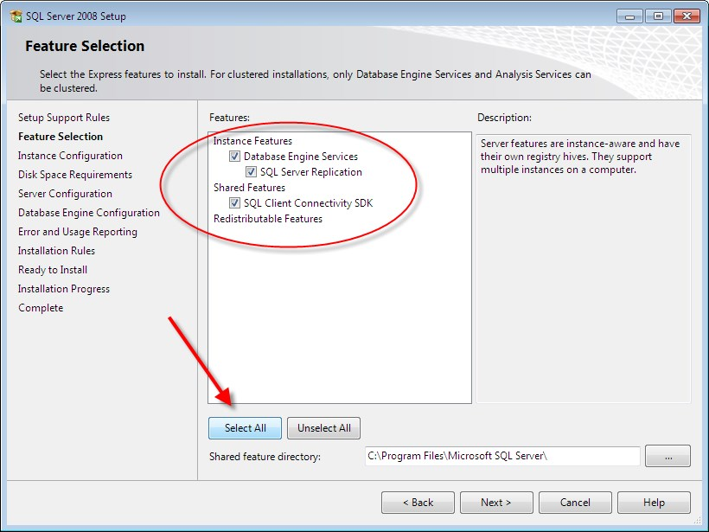

## Change from Named Instance to Default Instance

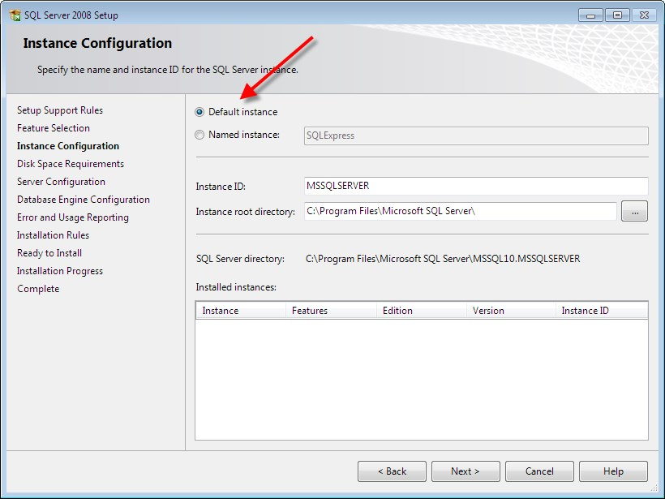

If you cannot install the default Instance you already have a version of SQL installed.

## Press Next

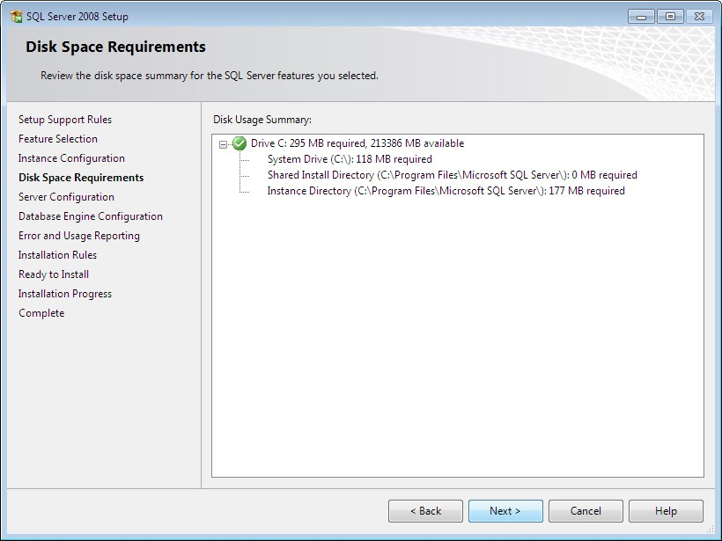

## Select the ‘NT AUTHORITY\NETWORK SERVICE’ for SQL Database Engine

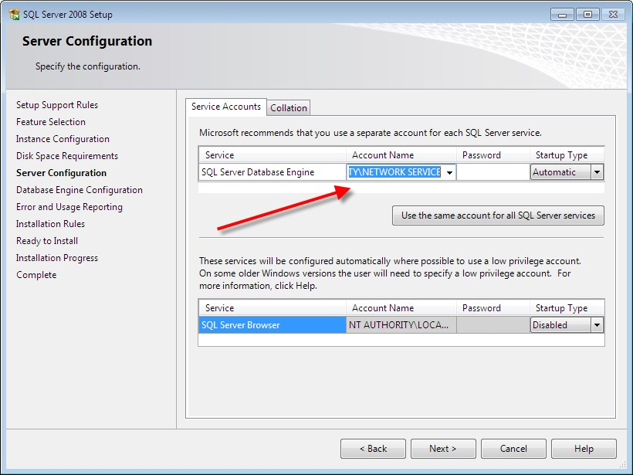

## Be Sure that Windows Authentication Mode is selected, and hit the ‘Add Current User’ button so your user name appears in the ‘Specify SQL Server Administrators’ box

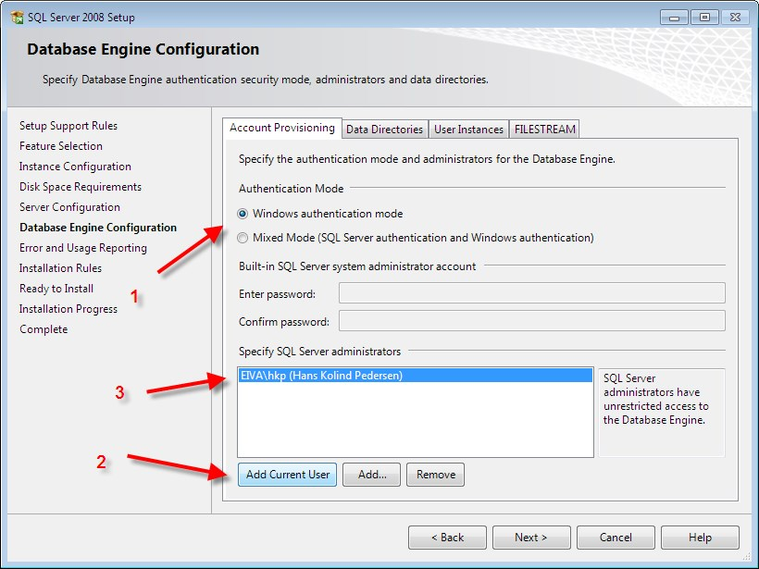

## Hit next on the ‘Error and Usage Reporting’

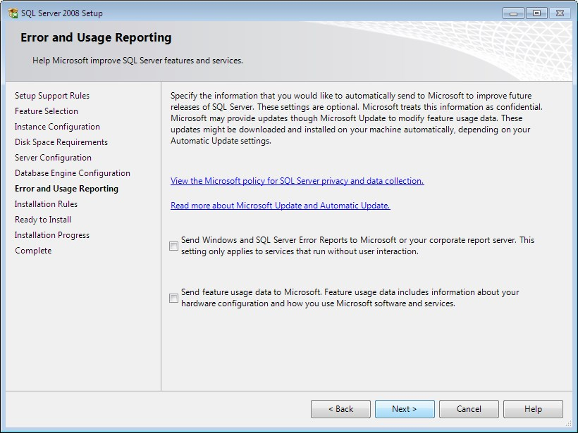

## Hit Next Again

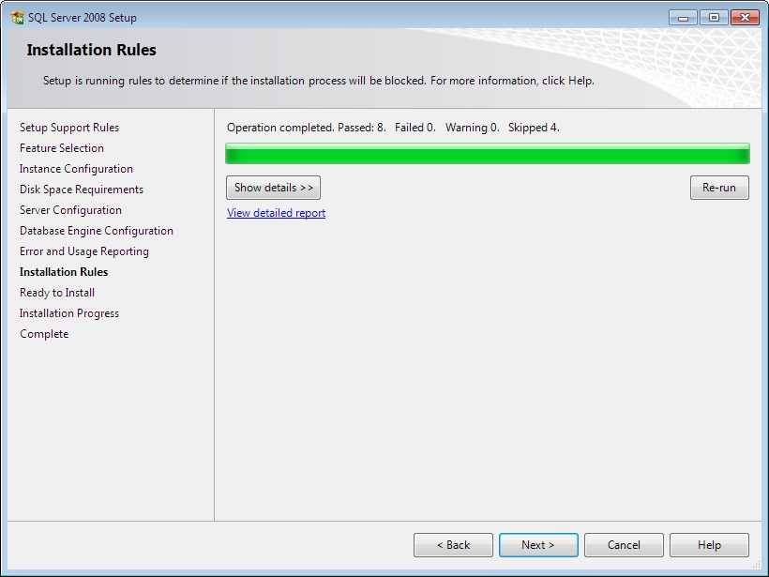

## And finally install

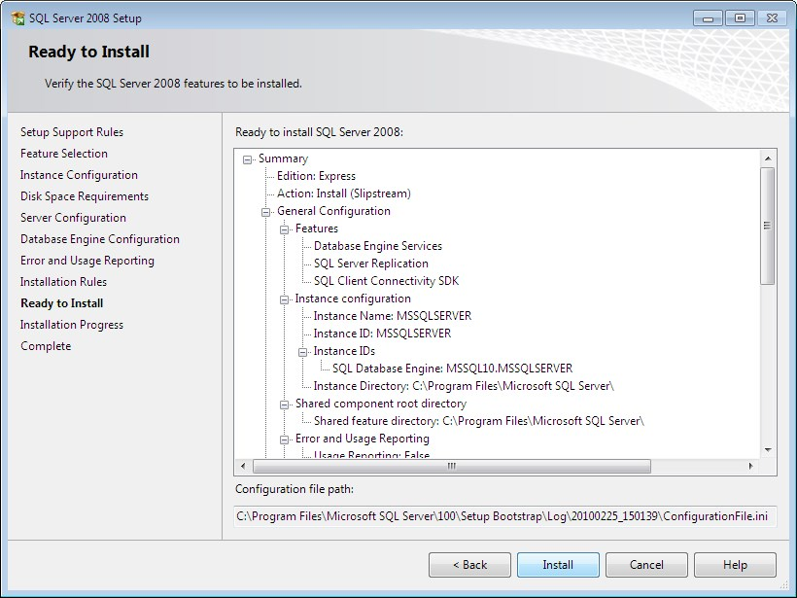

## And Next

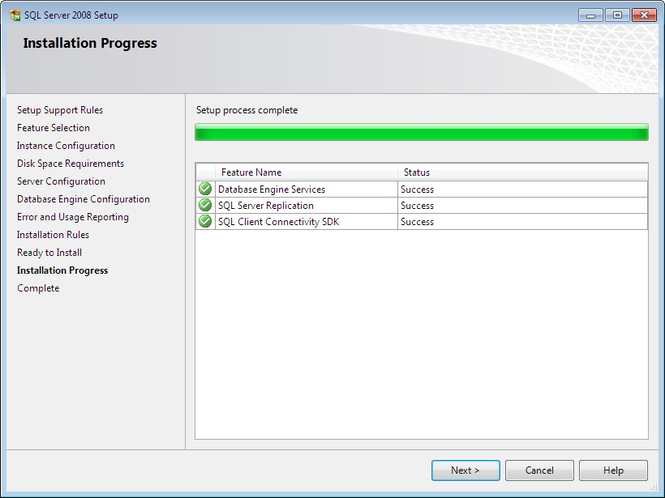

## And Close

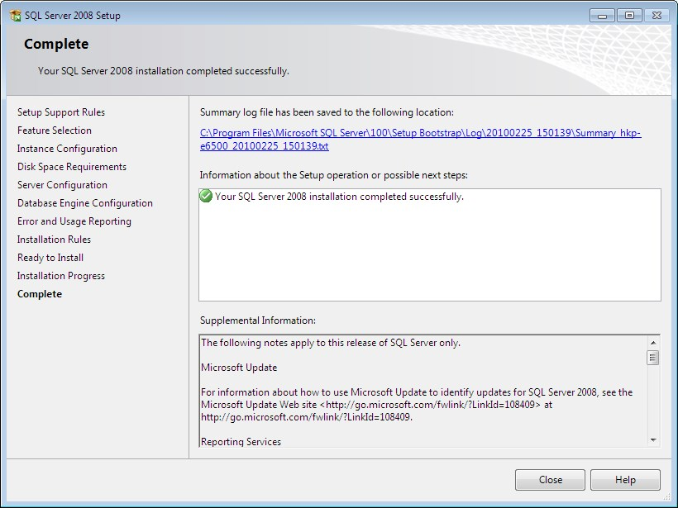

## Then go to the following Link

<http://willow.evacchair.co.uk/software/publish.htm>

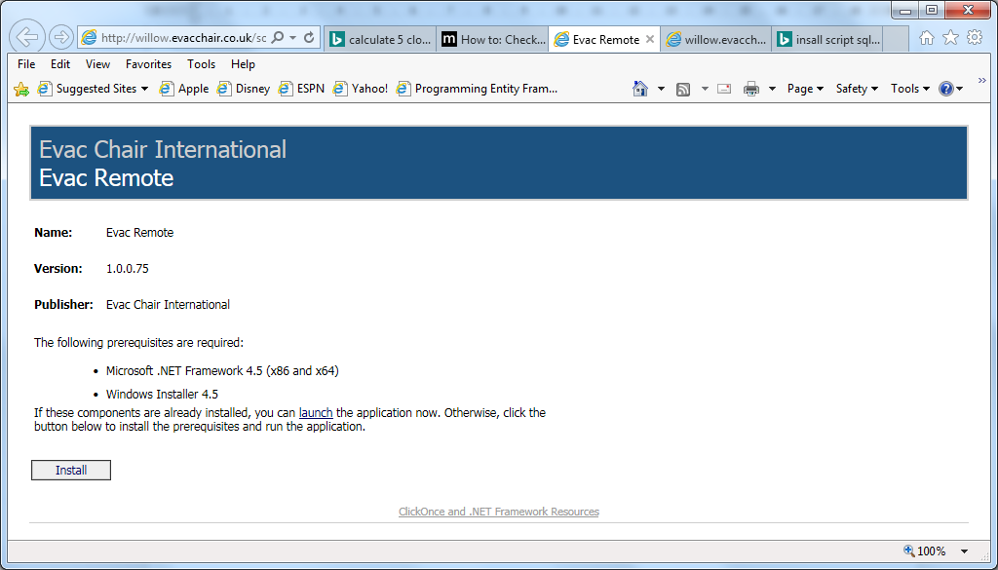

### And Click Install and then Click Run



## Click Install

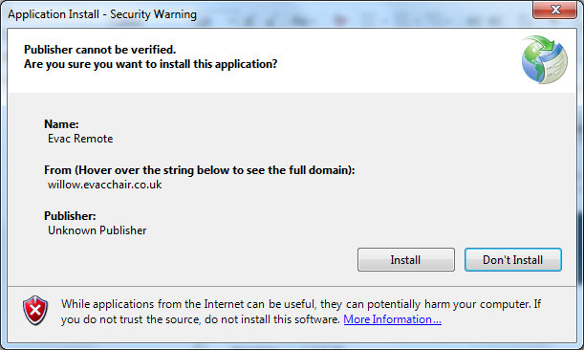

### Once finished you will have a New Icon on your desktop for Evac Remote and the program will load for the first time.